周恩来：

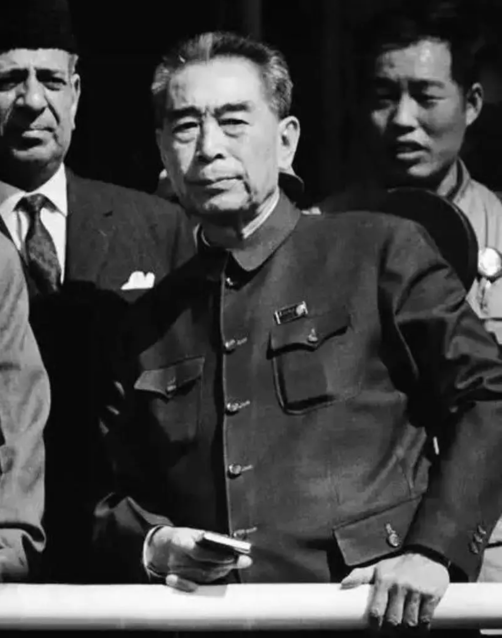

生平介绍：周恩来，1898年3月5日出生于江苏淮安，是中国共产党的主要领导人之一，中国人民解放军的主要创建人之一，中华人民共和国的开国元勋。

成长经历：周恩来早年参与了中国共产党的创建，并在红军中担任重要职务。

长征历程：在长征中，周恩来负责督促军事准备计划的实施，他坚定红军指战员革命必胜的信念，并在极端恶劣的环境下，保持着严明的纪律和乐观向上的革命精神。

突出贡献和英勇事迹：周恩来在长征中工作特别忙碌，负责军委的主要责任，每到驻地，就叫人架起电线，接收各军团的电报，挂起地图，以便观察和抉择行军、作战的路线。他在过草地时，因疲劳过度、营养不足而病倒，连续高烧40摄氏度不退，多日昏迷不醒。在这种情况下，他仍然坚持工作，直到被战士们抬出草地。周恩来的坚持和毅力，对红军的士气和战斗力有着极大的鼓舞作用。

**Biography**: Zhou Enlai, born on March 5, 1898, in Huai'an, Jiangsu, was one of the key leaders of the Chinese Communist Party, a principal founder of the People's Liberation Army, and a founding father of the People's Republic of China.

**Early Life**: Zhou Enlai was involved in the founding of the Chinese Communist Party and held significant positions within the Red Army.

**Long March Journey**: During the Long March, Zhou Enlai was responsible for supervising the implementation of military preparation plans. He maintained a firm belief in the revolutionary victory of the Red Army and upheld strict discipline and an optimistic revolutionary spirit in extremely harsh conditions.

**Outstanding Contributions and Heroic Deeds**: Zhou Enlai was particularly busy during the Long March, bearing major responsibilities for the Military Commission. At each stop, he would have telegraph lines set up to receive messages from various corps and hang maps to decide on marching and combat routes. While crossing the grasslands, he fell ill due to exhaustion and malnutrition, suffering from a persistent high fever of 40°C and remaining unconscious for days. Despite this, he continued to work until soldiers carried him out of the grasslands. Zhou Enlai's perseverance and determination greatly inspired the morale and fighting spirit of the Red Army.

朱德：

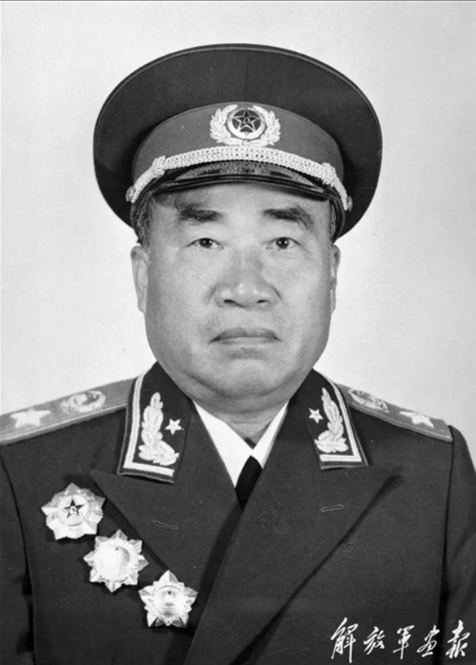

生平介绍：朱德，1886年出生，是中国共产党、中国人民解放军和中华人民共和国的主要缔造者和领导人之一。

成长经历：朱德早年参加辛亥革命，后加入中国共产党，参与领导了南昌起义，是红军的主要领导人之一。

长征历程：在长征中，朱德担任红军总司令，负责指挥红军的军事行动。

突出贡献和英勇事迹：朱德在长征中表现出了坚毅顽强、勇猛无畏的军事才能。他不仅善于在指挥所里运筹帷幄，而且经常身先士卒，上阵冲杀。在红军面临绝粮断炊的困境时，朱德组织部队采摘野菜充饥，并编写了《吃野菜须知》的小册子下发到各连队，展现了他对战士的深切关怀。

**Biography**: Zhu De, born in 1886, was one of the principal founders and leaders of the Chinese Communist Party, the People's Liberation Army, and the People's Republic of China.

**Early Life**: Zhu De participated in the Xinhai Revolution in his early years, later joining the Chinese Communist Party. He played a leading role in the Nanchang Uprising and was one of the main leaders of the Red Army.

**Long March Journey**: During the Long March, Zhu De served as the Commander-in-Chief of the Red Army, responsible for directing its military operations.

**Outstanding Contributions and Heroic Deeds**: Zhu De demonstrated steadfast determination and fearless military prowess during the Long March. He excelled in strategic planning and often led by example on the battlefield. When the Red Army faced severe food shortages, Zhu De organized the troops to gather wild vegetables for sustenance and compiled a booklet titled "Guidelines for Eating Wild Vegetables," distributing it to each company, showing his deep care for the soldiers.

陈树湘：

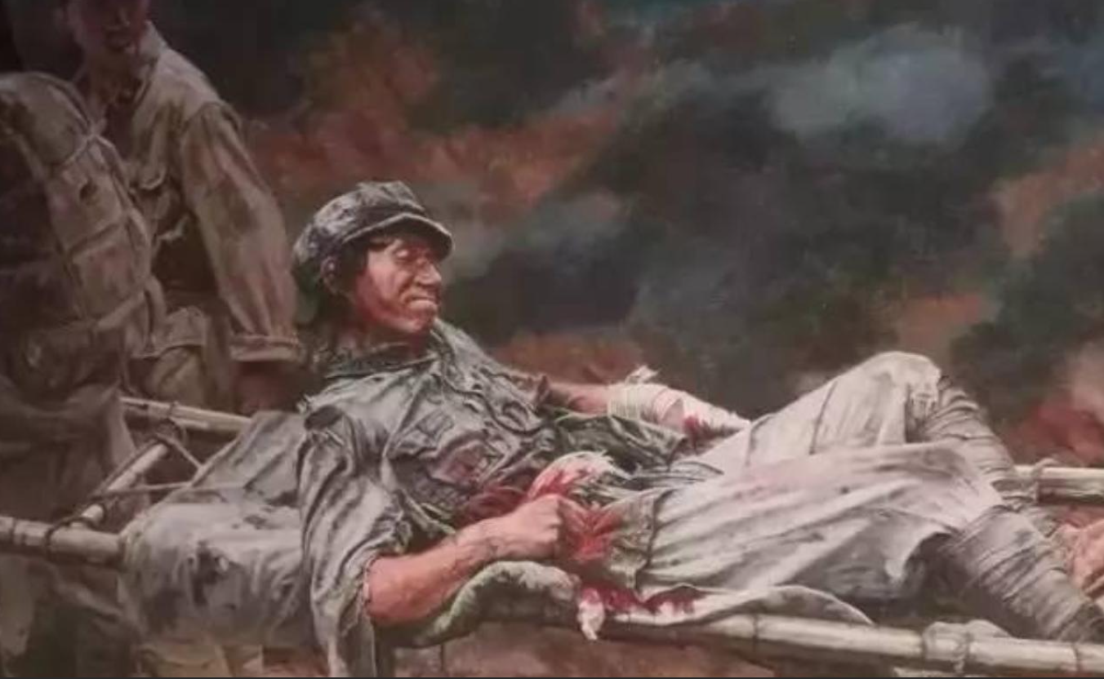

生平介绍：陈树湘，1905年出生于湖南长沙，是红军第34师师长。

成长经历：陈树湘在家乡遭遇大旱后，随父亲逃难到长沙，后来结识了毛泽东、杨开慧一家，并在他们的影响下投身革命。

长征历程：1934年10月，陈树湘率部参加中央红军长征，担任全军总后卫。

突出贡献和英勇事迹：在湘江战役中，陈树湘率领全师与十几倍于自己的敌人殊死激战四天五夜，付出重大牺牲。在战斗中，他腹部中弹，身受重伤，但仍然坚持指挥战斗。最终在被俘后，他趁敌不备，忍着剧痛，从伤口处掏出肠子，用力绞断，壮烈牺牲，时年29岁。

**Biography**: Chen Shuxiang, born in 1905 in Changsha, Hunan, was the commander of the 34th Division of the Red Army.

**Early Life**: After a severe drought in his hometown, Chen fled to Changsha with his father. There, he met Mao Zedong and Yang Kaihui's family, and under their influence, he joined the revolution.

**Long March Journey**: In October 1934, Chen Shuxiang led his troops in the Long March of the Central Red Army, serving as the rear guard for the entire army.

**Outstanding Contributions and Heroic Deeds**: During the Battle of the Xiang River, Chen Shuxiang led his division in a fierce battle against an enemy force ten times their size for four days and nights, suffering heavy casualties. Despite being severely wounded in the abdomen, he continued to command the battle. Ultimately, after being captured, he seized an opportunity, endured excruciating pain, and pulled out his intestines from the wound, breaking them to sacrifice himself heroically at the age of 29.

贺子珍：

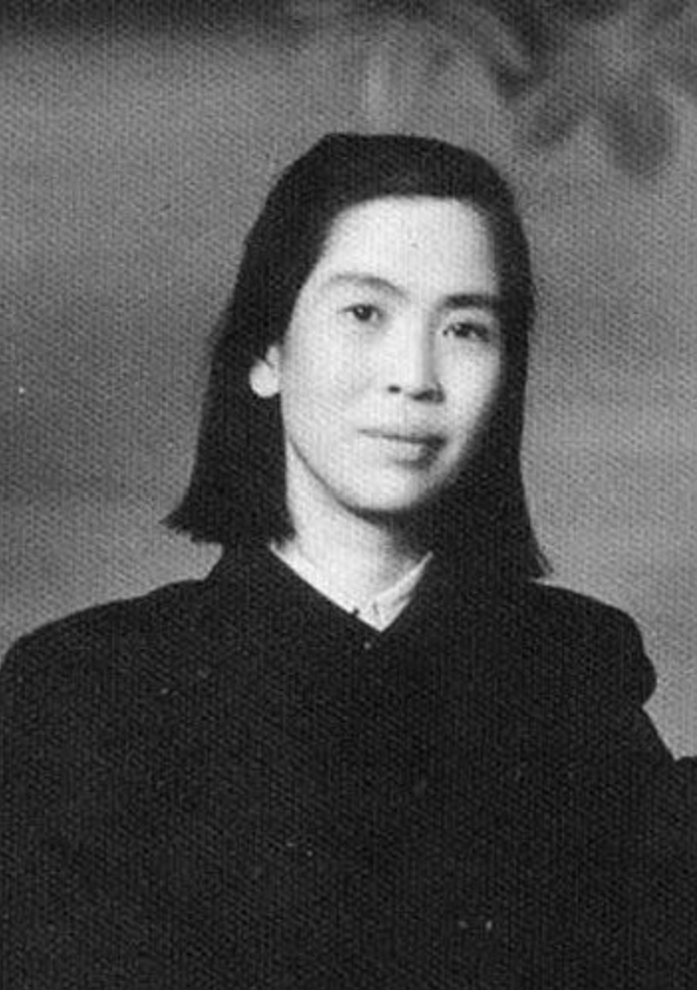

生平介绍：贺子珍，1909年出生于江西永新，是井冈山第一位女共产党员。

成长经历：贺子珍在大革命的疾风骤雨中成长，在井冈山血与火的枪林弹雨中成熟。

长征历程：1934年10月，第五次反围剿失败后，中央红军开始长征，贺子珍与毛泽东一起踏上了漫漫长征路。

突出贡献和英勇事迹：1935年4月初的一个晚上，女红军们刚拖着疲倦的身体赶到贵州盘县附近的五里排，突然敌机来袭，贺子珍为了抢救红军伤员，被炮弹炸伤，警卫员骑马去总卫生部请来李芝医生，为贺子珍救治。李芝先为贺子珍打了一支止血针，然后做了全身检查，发此刻她的头部、上身、四肢共有17块大小不一、深浅不一样的弹片，在没有实施任何麻醉的情景下，手术开始了。贺子珍疼得浑身大汗淋漓，眼里噙满泪花，却坚持一声不吭。身体浅层的弹片最终被一块块取出，而深入体内的弹片却难以取出，成为战争留给她的一份永久纪念。

**Biography**: He Zizhen, born in 1909 in Yongxin, Jiangxi, was the first female Communist Party member in Jinggangshan.

**Early Life**: He Zizhen grew up amidst the turbulent times of the Great Revolution and matured in the fierce battles of Jinggangshan.

**Long March Journey**: In October 1934, after the failure of the fifth counter-encirclement campaign, the Central Red Army began the Long March, and He Zizhen embarked on this arduous journey alongside Mao Zedong.

**Outstanding Contributions and Heroic Deeds**: In early April 1935, one evening, the female Red Army soldiers had just arrived at Wulipai near Pan County, Guizhou, exhausted. Suddenly, enemy planes attacked. He Zizhen was injured by shellfire while rescuing wounded soldiers. A guard rode to the General Health Department to bring Dr. Li Zhi for her treatment. Dr. Li first administered a hemostatic injection to He Zizhen and then conducted a full examination. She discovered 17 shrapnel pieces of varying sizes and depths in He Zizhen's head, torso, and limbs. The surgery began without any anesthesia. He Zizhen was drenched in sweat from the pain, tears welling in her eyes, yet she remained silent. The shrapnel near the surface was eventually removed piece by piece, but those deeply embedded became a permanent reminder of the war.

余秋里：

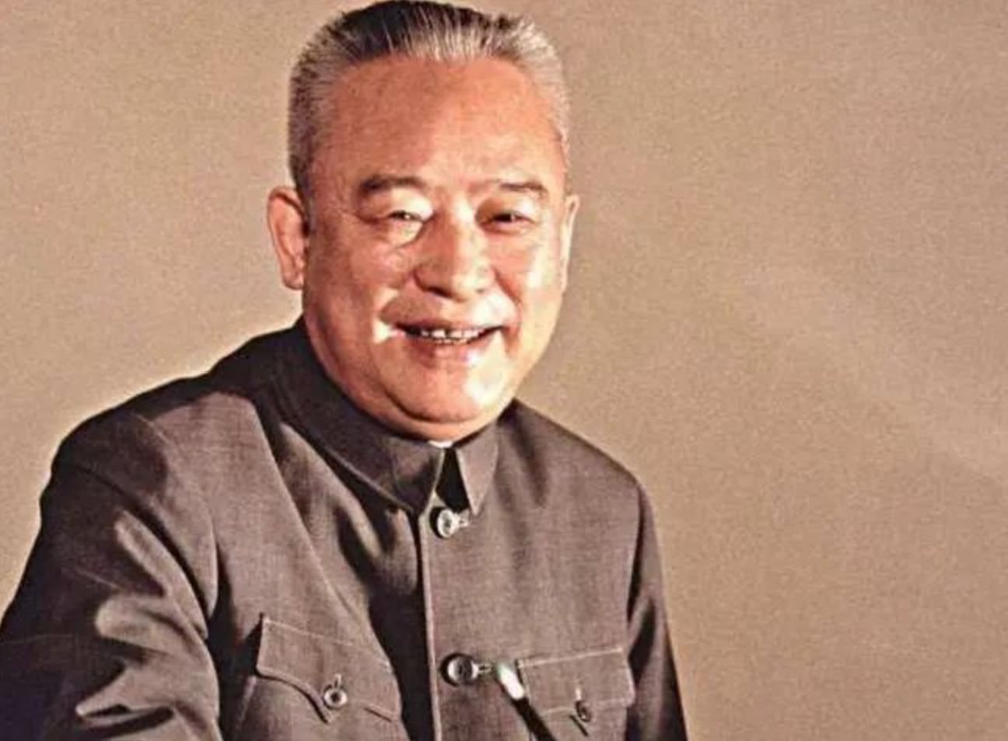

余秋里是我军卓越的政治工作领导者，新中国石油工业的创建者，经济工作的杰出领导人。长征时的一次战斗中他失去左臂，靠着剩下的一条手臂走到了革命胜利，1955年被授予中将军衔，人称“独臂将军”，也是中将中唯一担任过副总理职务的将军。

在一次战役中，余秋里的左臂被子弹打穿，露出骨头和筋腱，血流不止。当时，战争环境异常艰苦，缺医少药，根本没有条件及时做手术，他只好强忍着疼痛，随部队北上。行军途中，他的伤口感染爬满了白蛆。伤痛难忍时，他就把伤臂浸泡在冷水里止痛。一直到走出草地，陇南的医生才用一把剃头刀割掉腐肉，用普通锯条做了截肢手术。他用自己的言行，为红军战士做出了榜样，表现出大无畏的英雄气概。

Yu Qiuli was an outstanding leader in political work for our army, a founder of the new China's petroleum industry, and an exceptional leader in economic affairs. During a battle in the Long March, he lost his left arm but persevered with his remaining arm until the revolution's victory. In 1955, he was awarded the rank of Lieutenant General and was known as the "One-Armed General," the only general of his rank to have served as Vice Premier.

In one campaign, Yu Qiuli's left arm was pierced by a bullet, exposing bone and tendons, and bleeding profusely. The war conditions were extremely harsh, with a severe lack of medical supplies, making timely surgery impossible. He had to endure the pain and continue north with the troops. During the march, his wound became infected and was infested with maggots. When the pain was unbearable, he would soak his injured arm in cold water to relieve it. It wasn't until they emerged from the grasslands that a doctor in Longnan used a razor to remove the decayed flesh and performed an amputation with an ordinary saw blade. Through his actions, he set an example for the Red Army soldiers, demonstrating fearless heroism.